Canadian History 1850-1890 Causes and Consequences
What type of forces can bring about change? Examining the cause and consequences of events in history.
Teacher notes are highlighted in yellow (please make a copy and erase teacher notes before giving to students)

Engage | What makes something a force? What forces bring about change?  Develop a criteria in padlet  Teacher criteria to facilitate conversation: a push that brings about change in a positive or negative way  Has a long lasting effect  Did it have a cause or consequence?
Explore | Synopsis on main events - rank and order - (Immigration of fugitive slaves, the west coast gold rush, Confederation, the Metis uprising, the building of the Railway,)  While you are ranking and ordering be sure to add in Opportunities, Challenges and I Wonders for your top choice.  *Physically in the room - rank and order - one ladder/different post its* Put post its on Rocketbook pages - submit OCI to Google Classroom*
Explain | See your teacher for your Explain package. You will go deeper into articles/background information use resources from TC2, text books to provide students with additional information, and rank and order again using your force, and also your cause and consequence criteria  *Cause and Consequence video is linked to review criteria*  Use Adobe Spark for your new Rank/Order - be sure to submit your Adobe Spark in Google Classroom
Elaborate | Rank and Order Ladder - which of these events had the greatest consequences for the following groups  Catholic Canadians, fugitive slaves, Metis, French Canadians, Chinese Canadians, students in Canada. Students will explain their responses in Flipgrid, be sure to create a new Flipgrid account for your students
Evaluate | Looking at ladder again with Group - reorder events from the perspective of your chosen group. What were the short and long term impacts of the event and is it still felt today?  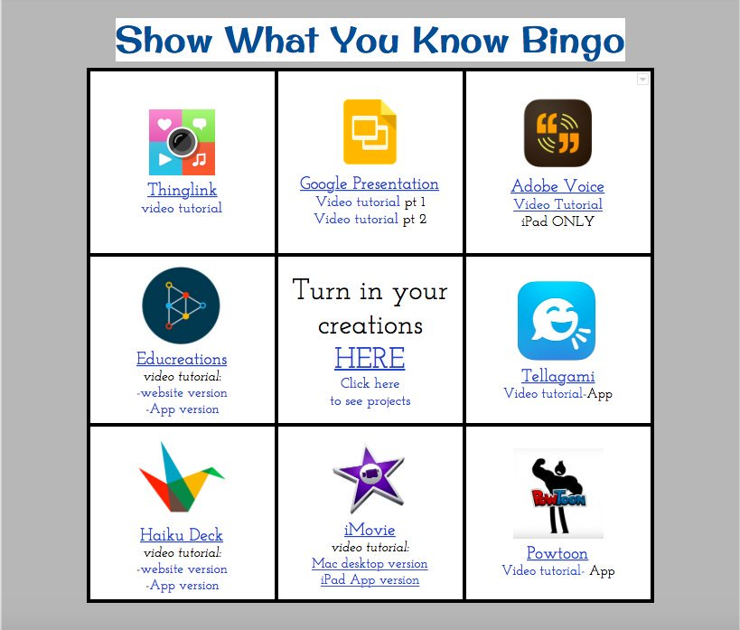  Be sure to review the success criteria before you submit your show what you know.  Complete your self reflection form  (Create a new copy of the self reflection form and change the link)

