Lesson 7: Common Angles
Learning Goals:

- Estimate the size of a given angle by comparing it to angles of 30°, 45°, 60°, 90°, 180° and 360°

- Construct reasonably accurate diagrams of the angles 180°, 90°, 45°, 30°, and 60°, by dividing a given circle into the appropriate number of parts.

- Accurately identify different types of angles.

Topic: Common Angles

Before starting the activities read each of the statements below and imagine what is happening in each case. How would you visually represent each statement?
He made a 360 on the icy road.
She made a 90 right turn.

He was going to download an album, but after talking to a friend, he did a 180 and decided not to buy it.

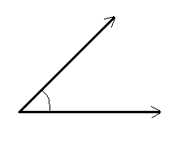
Measuring Angles
- An angle is a figure formed by two line segments that originate from the same point (a vertex)
- We measure angles in degrees
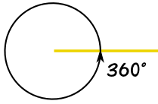
- The symbol for a degree is $∘$
- There are 360$∘$ in a circle

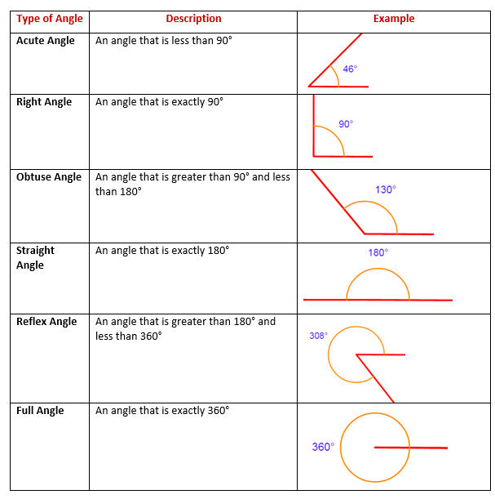
Common Angles

Fractions of a Circle
A full circle has 360$∘$ which we can also relate to fractions. For example ½ a circle can be visually represent as the shaded region we see below. The corresponding angle measure is 360$∘÷$2, or 180$∘$ .
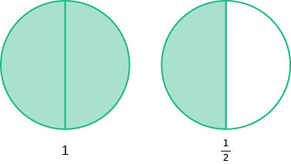
Example(s):

1) Estimate the degrees of the given angle.
Since it appears to be somewhere between 90 and 60 degrees and seems more than halfway between 60 and 90 (which is 75) then a good estimation would be 80 degrees.
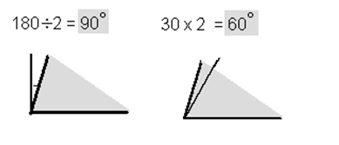
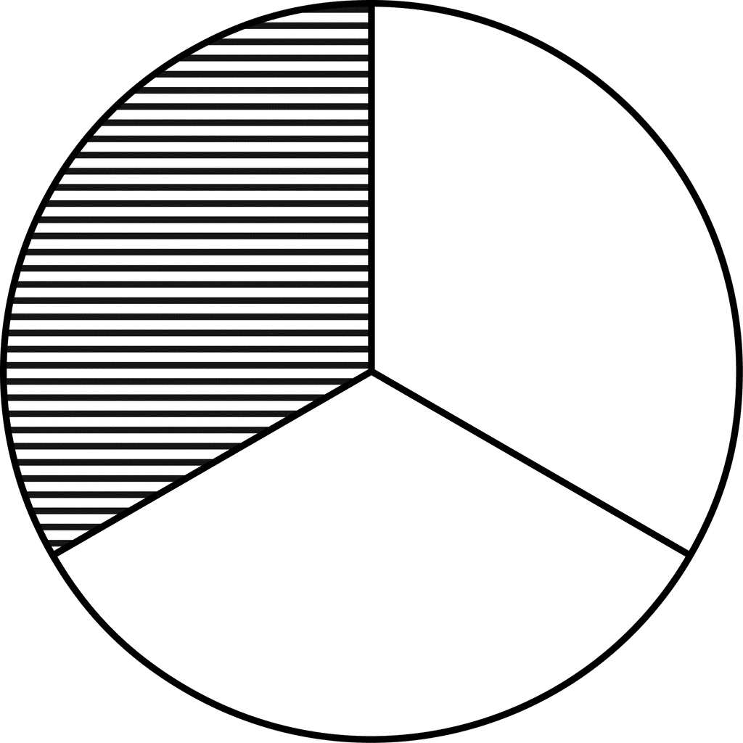
2. a) What fraction of the circle is represented by the shaded region?
The circle has 3 sections, which means the denominator will have a value of 3.

The circle has 1 shaded region, which means the numerator will have a value of 1.

Therefore, we can say that the fraction of the circle represented by the shaded region is ⅓.

b) What is the measure of the angle of the shaded region?
To determine the measure of the angle we divide 360$∘$ by the number of sections.
360$∘÷$3 = 120$∘$

Practice Questions:

1. Using the Common Angles chart, label each angle indicated below:
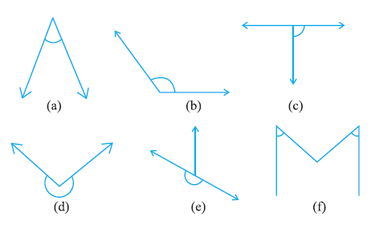

2. Estimate the degrees of the given angles:

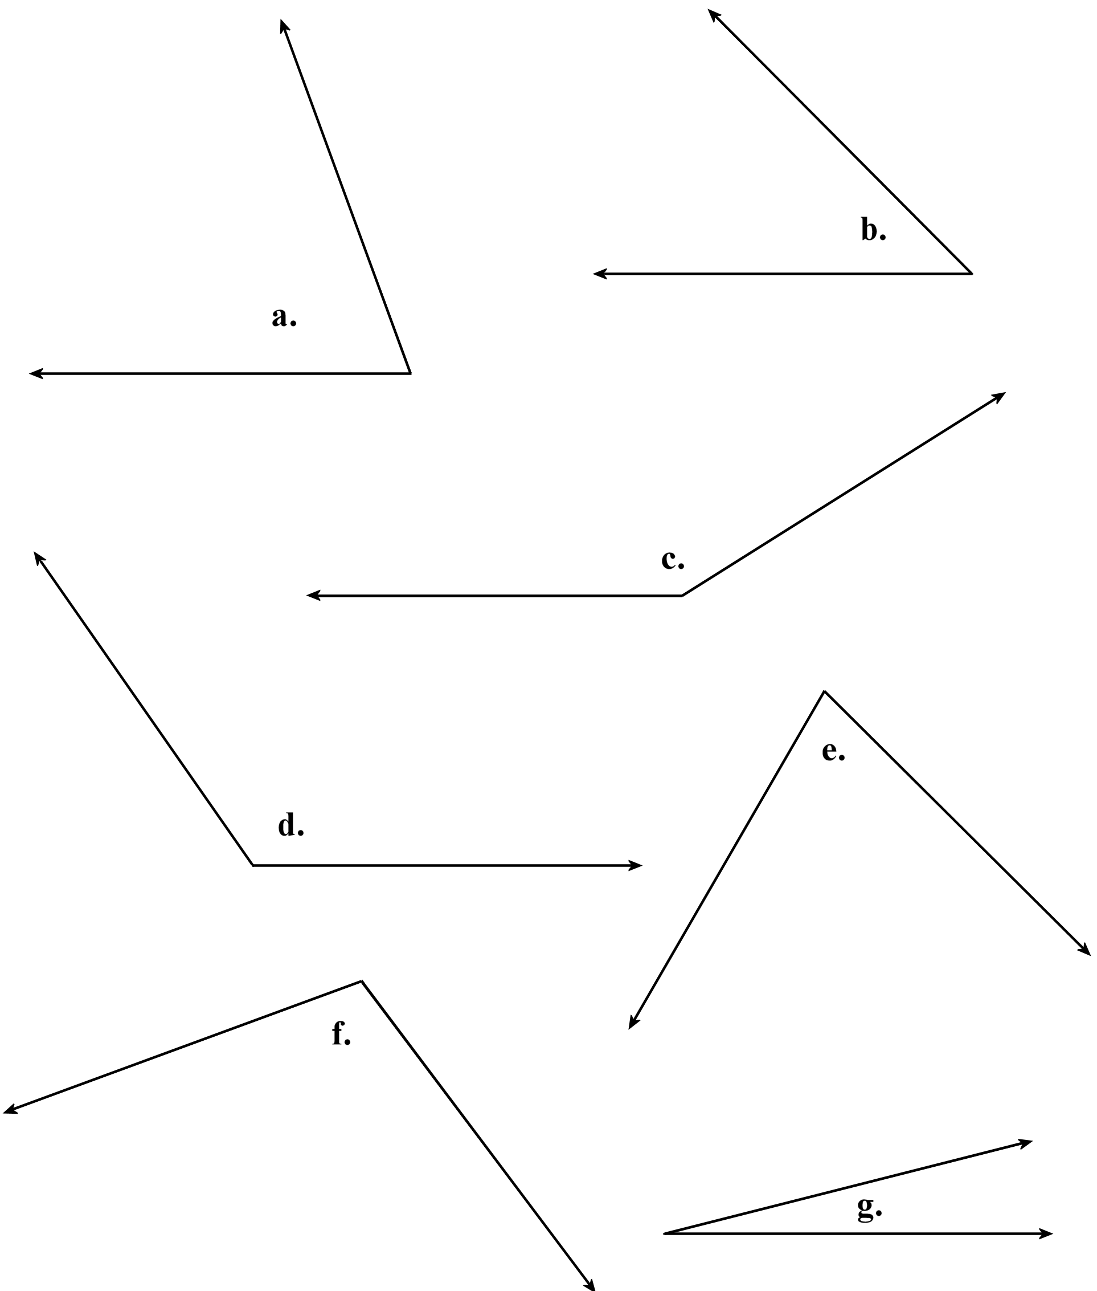

3. Identify the fraction of the circle that is represented by the shaded region and the measure of the angle.

A.
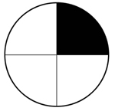

B.
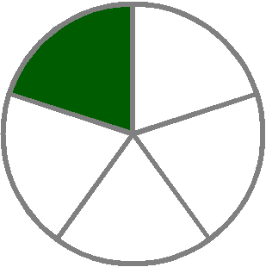

C.

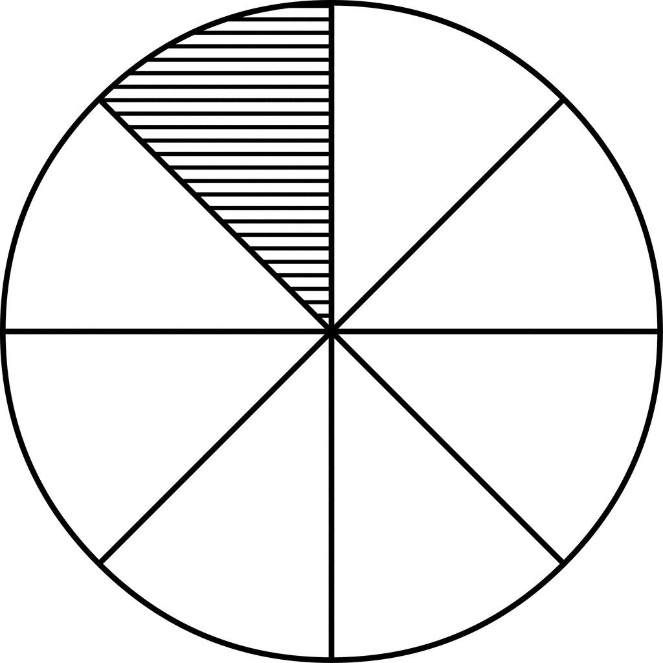

D.
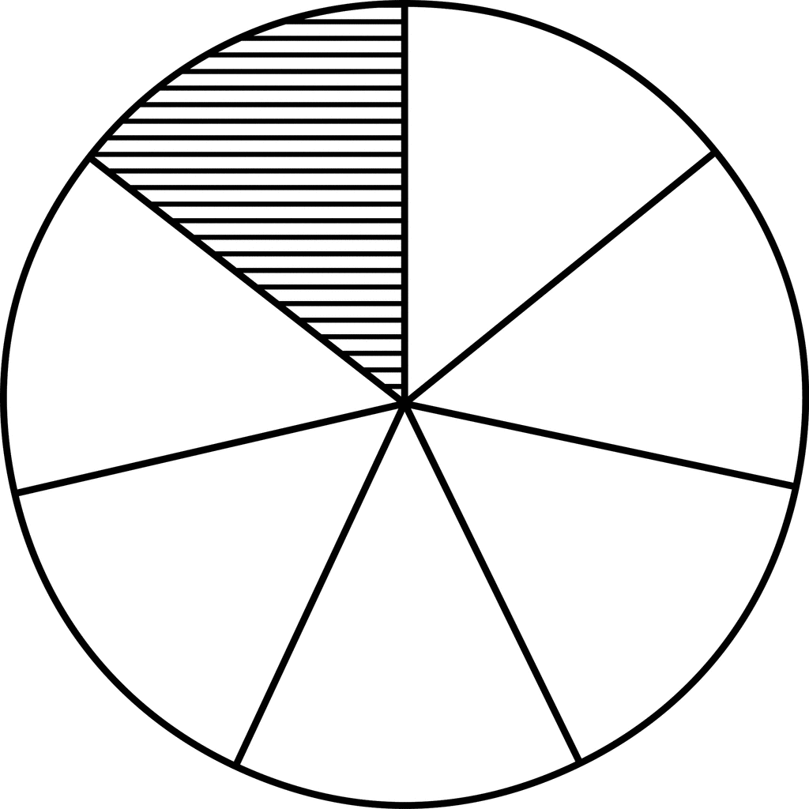

Assessment Strand 3 Lesson 7

1) Identify the angles below as either acute angle, reflex angle, right-angle, obtuse angle, or straight angle.

2) Estimate the degrees of the given angles:

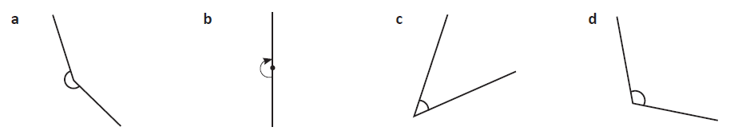

3. Identify the fraction of the circle that is represented by the shaded region and the measure of the angle.

