Lesson 6: Volume of Cylinders and Prisms
Learning Goals:

- To find the volume of rectangular prisms
- To find the volume of cylinders when given a radius or diameter
- To solve word problems involving volume

Topic: Volume of Cylinders and Prisms

Volume is the amount of space a figure occupies. It is a 3-Dimensional measurement, so its units will be ‘cubed.’ (m³, cm³, in³….) In general, the volume of a prism can be calculated by multiplying the area of the base by the height.
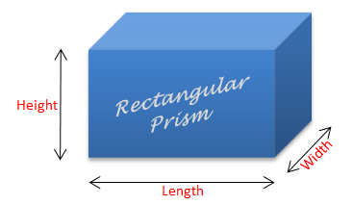
A rectangular prism has six rectangular faces. It has a rectangle as a base. Its volume can be calculated by:
V = l x w x h
Or
Volume = length x width x height

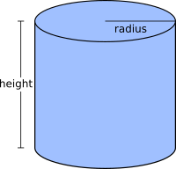
A cylinder is a prism that has a circle as a base. Its volume can be calculated by:
V = $π$r²h
Or
Volume = pi x (radius x radius) x height

Example(s):

1. Calculate the volume of the prism to one decimal place:
a)
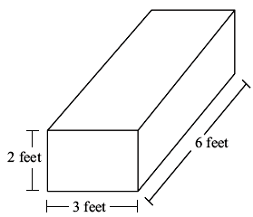
Step 1 Select the correct formula.
V = l x w x h
Step 2 Substitute the values of the dimensions and solve.
V = l x w x h
= 3 x 6 x 2
= 36 ft³

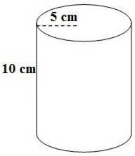
b)

Step 1 Select the correct formula.
V = $π$r²h

Step 2 Substitute the values of the dimensions and solve. Remember to simply r² first.
V = $π$r²h
= 3.14 x ( 5 x 5) x 10
= 3.14 x 25 x 10
= 785cm³

Practice Questions:

1) Calculate the volume of each figure below to one decimal place.
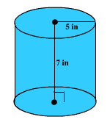 | 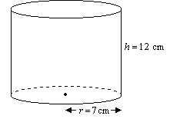
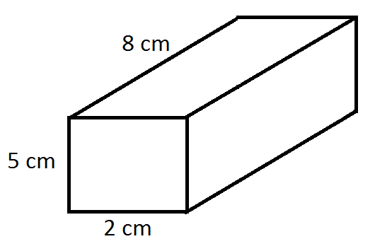 | 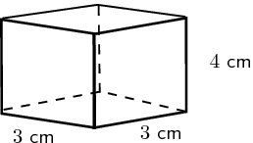
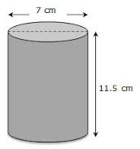 | 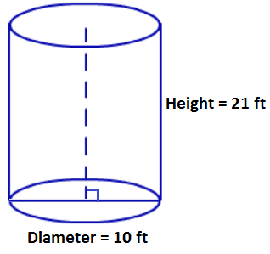
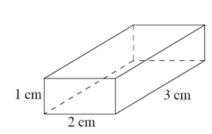 | 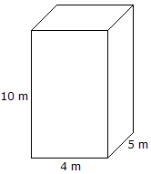

2. A rain barrel is 2m tall and has a radius of 0.6m. How much water can it hold?
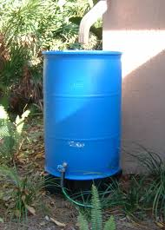

3. The local park has decided to build a pond with the dimensions below. How much soil will be removed from the ground?

d=2m
h=0.5m

Strand 3 Lesson 6 Assessment

- What is the volume of the prism below:

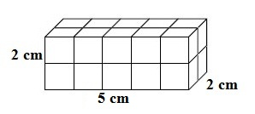

- Monster Energy drinks are redesigning their cans. The new can needs to hold approximately twice as much liquid. The original can is shown below:

h=10cm
d=6cm
Monster

The designers are choosing between two options outlined below:

Option A | Option B
Double the diameter, but keep the height the same. | Keep the diameter the same, but double the height.

- Determine which of the two options listed above does not meet the requirement of doubling the volume.

- Clearly state your reasoning and the necessary calculations to support your findings.

- Show all steps needed to support your answer.

