Lesson 5: Calculating the Area of Circles
Learning Goals:

- To use the formula to calculate area of a circle.
- To calculate area given a diameter
- To calculate area of a semi-circle or quarter circle
- To solve word problems involving area

Topic: Calculating Area of Circles

Area of a Circle

Area is the space inside an object.

The units of measure are always squared (i.e. 150 cm²).

The radius of a circle is the distance from the centre to any point on the circumference of the circle.
Formula for Area of a Circle
A = $π$r²
= 3.14 x (r x r)
*It is important to square the radius before multiplying by pi*

Example(s):

1. Calculate the area of the circle.

r=8cm
Step 1 Write the required formula.
A = $π$r²
Step 2 Substitute the value of the radius into the formula and calculate. Be sure to square the radius before you multiply it by pi.
A = $π$r²
= 3.14 x (8x8)
= 3.14 x 64
= 200.96cm²
2. Calculate the area of the circle.

d=7cm
Step 1 Write the required formula.
A = $π$r²
Step 2 Substitute the value of the radius into the formula and calculate. Because you are given a diameter of 7cm, you must divide it by 2 to determine the radius (7$÷$2 = 3.5) A = $π$r²
= 3.14 x (3.5x3.5)
= 3.14 x 12.25
= 38.465cm²
= 38.5cm²
3. Calculate the area of the figure.
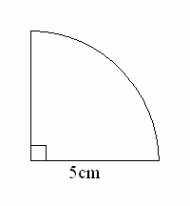
Step 1 We can see this is not a full circle, so we will have to modify the formula. This shape represents ¼ of a circle, so we will divide the total area by 4.
A = $(π$r²)$÷$4

Step 2 Substitute the value of the radius into the formula and calculate.
A = $(π$r²)$÷$4
= 3.14 x (5x5)$÷$4
= 3.14 x 25 $÷$4
= 19.625cm²

4. A circular display has a radius of 1.7 m. How much plastic is required to cover the display?

r=1.7m
Step 1 We are looking for the amount of material to cover the circular display, so, we need to determine the area.
Step 2 Write the required formula.
A = $π$r²

Step 3 Substitute the value of the radius into the formula and calculate.
A = $π$r²
= 3.14 x (1.7x1.7)
= 3.14 x 2.89
=9.07m²
Step 4 Write a final statement.
Approximately 9m² of plastic is needed to cover the display.

Practice Questions:

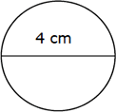
1. Calculate the area of each circle to 1 decimal place.
a.

b.
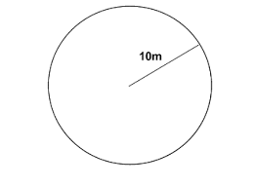

c.
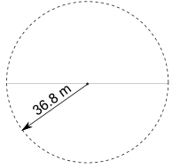

d.
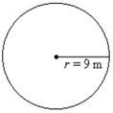

e.
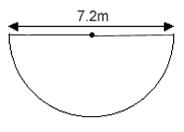

2. How much material do you need to cover a circular pool that has a diameter of 6m?

3. You have been asked to paint the surface of your neighbourhood splash pad with a special non-slip paint. The distance from the center of the splash pad to the outside is 5.2m. How much paint do you need?

Strand 3 Lesson 5 Assessment

1. Calculate the area of each circle to one decimal place.

r=5mm | d=140.5m
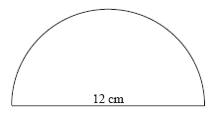

2. Ikram is making a circular quilt and has already bought 6m² of material. She wants her quilt to have a radius of 1.5m. Does she have enough material to make her quilt?

