Lesson 4: Perimeter of Composite Figures

Learning Goals:

- Solve problems requiring the calculation of the perimeter of composite figures made up of straight line segments and half-and quarter circles
- Apply and adapt appropriate formulas to solve a given problem

Topic: Perimeter of Composite Figures

Perimeter is the distance around an object. If that object is a circle then the perimeter is called circumference. We use formulas to calculate perimeter.
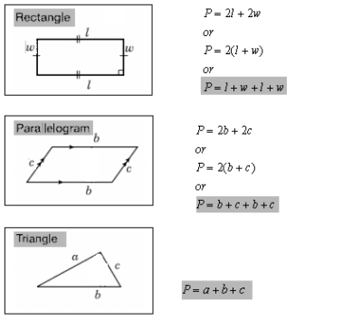
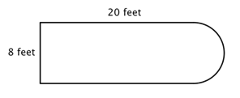
Composite figures are made up of simple shapes such as triangles, rectangles and circles.
Here we have a composite figure composed of a rectangle and a semi-circle. We can use our understanding of the perimeter formulas to determine the perimeter of these composite figures.

Example(s):

Find the perimeter of each of the following shapes.
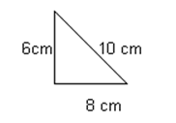
a.
Step 1 Select the correct formula
P = a + b + c
Step 2 Substitute the given dimensions and solve
P = a + b + c
= 8 + 10 + 6
= 24 cm
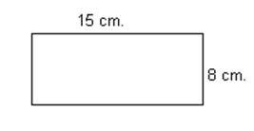
b.

Step 1 Select the correct formula
P = l + l + w + w
Step 2 Substitute the given dimensions and solve
P = l + l + w + w
= 15 + 15 + 8 + 8
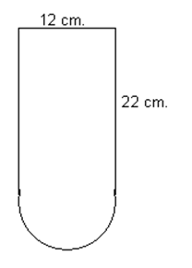
= 46 cm
c.

Step 1 Look at the figure and recognize the shapes present include a rectangle and semi-circle.
Step 2 Adapt the perimeter formulas.
This figure only include 3 sides of the rectangle since the 4th side is ½ of a circle. So perimeter is
P = l + l + w + ($π$ x d$÷$2)

Recall circumference of a circle is C = 3.14 x d
Because we have half a circle, we divide by 2.
Step 3 Substitute the given dimensions and solve
P = l + l + w + ($π$ x d$÷$2)
= 22 + 22 + 12 + ($π$ x 12 $÷$ 2)
= 74.84 cm
Practice Questions:

1. Find the perimeter of the following shapes:
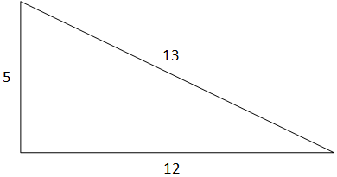
a.

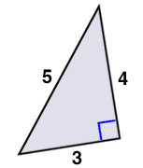
b.

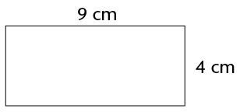
c.

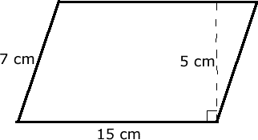
d.

e.
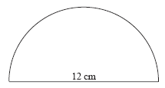

2. Find the perimeter of the following shapes:
a.
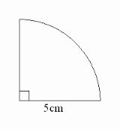

b.
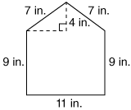

c.
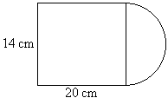

d.
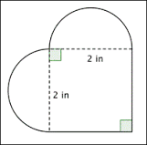

2. A basketball court measures 41.6’ by 15.6’. What is the perimeter of the basketball court?

3. A basketball has the radius of 15 cm. What is the minimum circumference needed for the rim of the basketball hoop?

Strand 3 Lesson 4 Assessment:

- Calculate the perimeter of the following figures:

A.
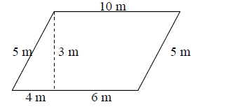
B.
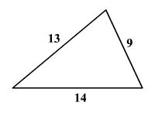
C.
D.
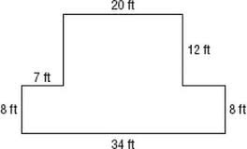

- A racetrack has inside and outsides as shown below. How much farther does a person have to run if they run on the outside of the track instead of the inside?
