Lesson 4: Cheques and Pay Stubs
Learning Goals:

- To identify the information contained on a cheque
- To correctly fill in a cheque
- To identify the information contained on a pay stub and understand the deductions that are present

Topic: Cheques and Pay Stubs

Cheques:

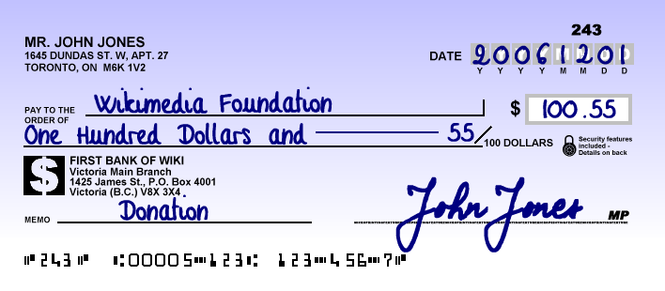
Cheque is an agreement of payment between two individuals or organizations. When you write a cheque, you are agreeing to pay another individual or organization money that you owe them and you are instructing your bank to make that payment. All cheques must be processed through the payments system. When you deposit a cheque into your account, your bank will send the cheque to the bank of the person who wrote the cheque. That bank makes sure that the cheque is legitimate and there are enough funds in the cheque-writer’s account to cover the cheque, and then sends the funds to your bank.

If you deposit a cheque and there is not enough money in the cheque-writer’s account to cover the cheque, the cheque will be returned to your bank as NSF or non-sufficient funds. The person who wrote the cheque will be charged a penalty fee as a result.

Today, cheques are slowly being phased out. Most stores will no longer accept cheques as a form of payment. One instance in which cheques are still used is when you are looking for an apartment to rent. Landlords will ask for you to provide post-dated cheques for each month of your lease agreement. A post-dated cheque is a cheque that cannot be cashed until a specific date in the future. Landlords hold onto these post-dated checks as an insurance policy to ensure their tenants pay their rent on time.

Anatomy of a Cheque:
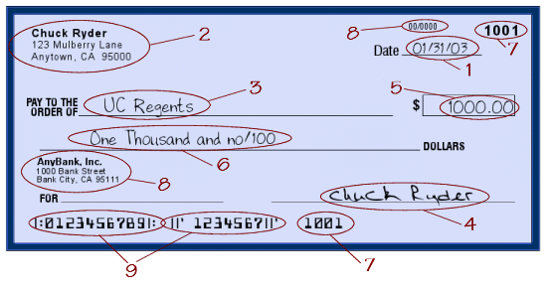
1 | Date | the date the check is written (cannot be a future date)
2 | Maker | person/business who writes the check - the name will be printed on the check
3 | Payee | person/business to whom the check is written
4 | Signature line or lines | two or more signatures can be required on a check
5 | Written amount | the amount written in number
6 | Legal amount | the amount written in words
7 | Check number | which is printed on the check and appears in the MICR line on the bottom of the check
8 | Banking information | both the name of the bank and the American Banking Association number appear on the check
9 | Account and routing numbers | appear on the bottom of the check in MICR line. The routing (ABA) number is always 9 digits long, and is always between a line and a colon (|:xxxxxxxxx|:).​

Paychecks/Stubs/Slips
Receiving a paycheck can be the highlight of a person’s day. If the paycheck is smaller than expected, it can also be a concern. By learning about paychecks, paycheck deductions, and required employment forms, a person will be able to understand the amount received on their paycheck and ensure they have been paid the correct amount from the employer for the time worked.
Today, there are three ways an employer may handle paying his/her employees:
1 | Paycheck with pay stub attached | The employee is responsible for taking the check to the financial institution and depositing it into his/her personal account.
2 | Direct Deposit | An employer deposits the employee’s paycheck directly into the authorized employee’s financial institution account. On payday, the employee receives a written statement detailing the paycheck deductions. This is more secure than paystubs.
3 | Payroll Card | A payroll card is a prepaid card that is offered to employees as an alternative to paper paychecks or directly depositing wages into an employee’s financial institution account. Most payroll cards are smart cards, which have money electronically loaded onto them.

Anatomy of a Pay Stub

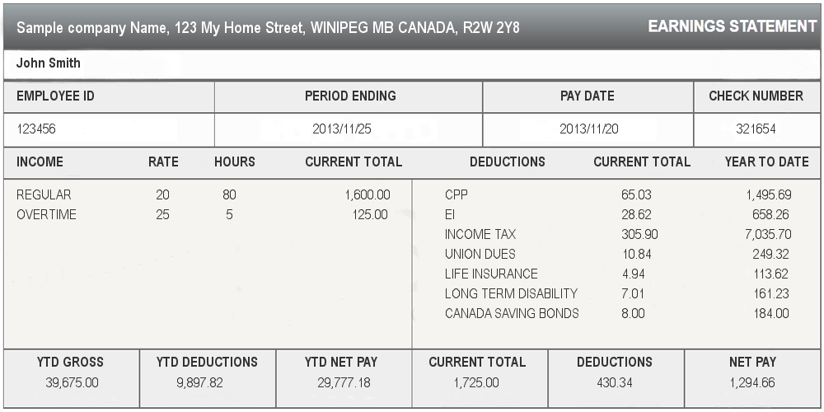

Employee ID | This is a number your employer uses to identify you as a worker in their system.
Period Ending | This tells you the time period for which you are receiving your earnings
Income | This is the part of the pay stub that shows you your hourly rate and hours worked (if you are an hourly employee) or your salary. For salaried employees, your hours are defaulted to 40 hours per week. It also includes your overtime (if hourly), any bonuses, or commissions for this pay period.  It’s important to note that this is your gross earnings, which is what you would make before taxes, contributions, and deductions.
Deductions | This is money that is taken away from your gross earnings. Common deductions include CPP (Canadian Pension Plan), EI (Employment Insurance), Income Tax (the government taxes your earnings to pay for public services like education, road maintenance…).
YTD Gross and Deductions | This shows how much you have earned this Year To Date (YTD) and how much has been deducted from your gross income.
Net Pay | Net Pay is the difference between your gross income and your deductions. This is the amount of money that ultimately ends up in your bank account.

Practice Questions:

- What is a cheque?

- What does NSF mean with respect to cheques?

- When might you be asked to provide a cheque?

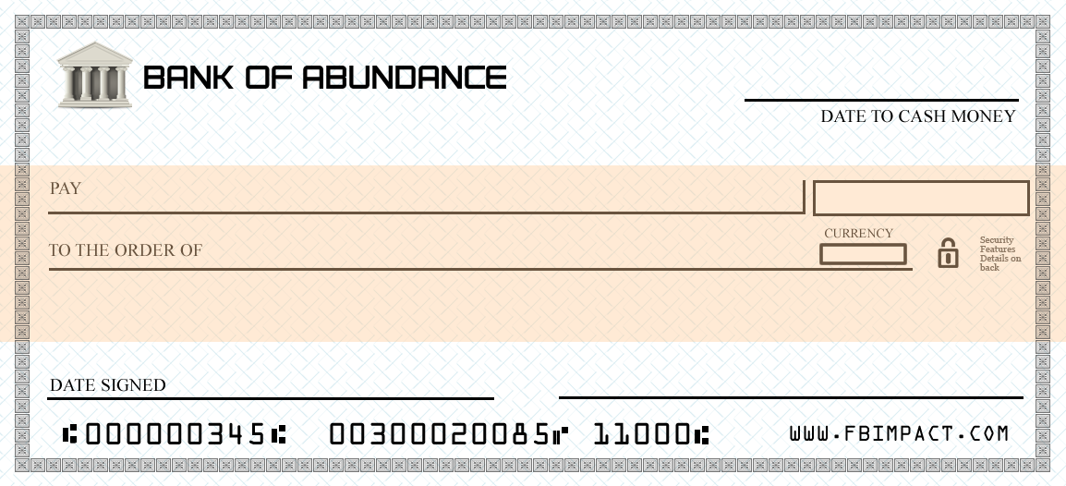
- Fill in the cheque below. You should use today’s date and your own signature. Imagine you are paying a landlord a deposit for the apartment rental. Your new landlords name is Carmichael Oakley and he is asking for a $300 deposit.

- Examine the pay stub below and identify the following components:

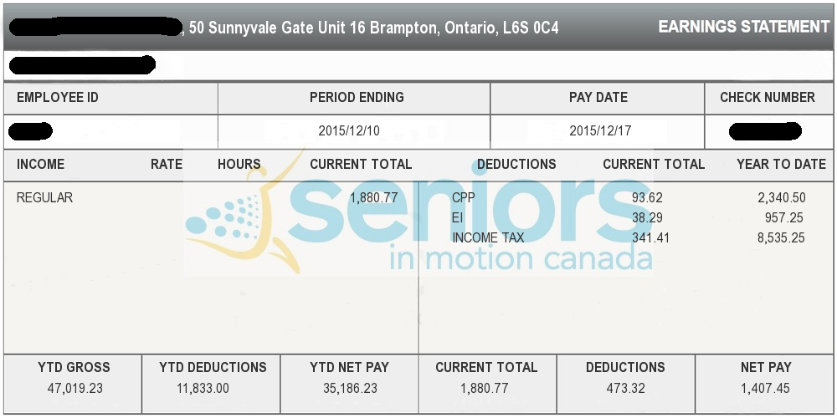

- The pay date was __________________________.
- The gross income earned this pay period was ________________.
- The amount deducted for EI this pay period was _____________.
- The Net Pay this period was _____________________.
- The total deductions for this pay period was ________________.
- The YTD deductions were ___________________________.
- The company issuing the paystub is_______________________.

Assessment: Strand 1 Lesson 4

1. Match the terms to the correct definition.

1. Net pay |  | a) Agreeing to pay another individual or organization money that you owe them and you are instructing your bank to make that payment.
2. Check |  | b) This is one of three ways an employer may handle paying his/her employees
3. Pay-stub |  | c) This is the difference between your gross income and your deductions.
4. Check number |  | d) which is printed on the check and appears in the MICR line on the bottom of the check

2. Answer the following questions as it relates to the paystub below.
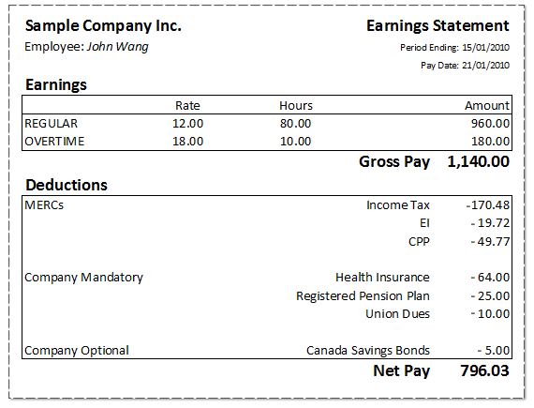
a) The pay date was __________________________.
b) The gross income earned this pay period was ________________.
c) The amount deducted for EI this pay period was _____________.
d) The Net Pay this period was _____________________.
e) The total deductions for this pay period was ________________.
f) The YTD deductions were ___________________________.
g) The company issuing the paystub is_______________________.

3. Fill out the check with the following information:

a) Today’s date
b) Amount: $126.36
c) Payable to: Access Alternative Programs
d) Sign the check with your signature

