Lesson 4: Time Zones
Learning Goals:

- To be able to accurately determine the time in different parts of Canada using the time zones.

Topic: Time Zones

- We used to tell time by looking at the position of the sun in the sky. The time often varied from one place to the next, and as travel became faster, this caused a lot of confusion.

- While the sun comes up in your location, it is setting for someone else. It wouldn’t make sense for all of us to be using the same time.

- On January 1, 1885 the world adopted standard time zones. Countries all over the world were divided into time zones based on longitudinal bands.

Example(s):

Use the Time Zone Map of Canada to answer the following questions:

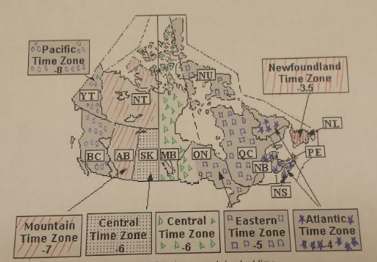

- If it was 5 p.m. in Ottawa, Ontario, what time is it in Vancouver, British Columbia?

If you look at the time zone map, Ottawa is in the Eastern Time Zone which is -5 and Vancouver is in the Pacific Time Zone which is -8. To go from -5 to -8 you would have to subtract 3. Therefore British Columbia is 3 hours behind Ottawa: 5pm - 3 hours = 2 p.m. Therefore it is 2 p.m in Vancouver

- Julie sends an email from Toronto, Ontario at 9 p.m. When you would expect this message to arrive in Charlottetown, P.E.I?

If you look at the time zone map, Toronto is in the Eastern Time Zone which is -5 and Charlottetown is in the Atlantic Time Zone which is -4. To go from -5 to -4 you would have to add 1. Therefore Charlottetown is 1 hours ahead of Toronto: 9 pm + 1 hour =10 p.m. Therefore it is 10 p.m in Charlottetown when it would arrive.

Practice Questions:

Use the Time Zone Map of Canada to answer the following questions

1) If it was 10am in Toronto, Ontario, what time would it be in Saskatoon, Saskatchewan?

2) If it was 6 pm in Winnipeg, Manitoba. What time would it be in Quebec City, Quebec?

3) What time zone is Winnipeg, Manitoba in?

4) Farah sends an email from Toronto at 10 p.m. When you would expect this message to arrive in each of these cities?
- Ottawa, Ontario

- Calgary, Alberta

- Victoria, British Columbia

- St. John's, Newfoundland

5) Kimesha lives in Jasper, Alberta and wants to call Stephanie at 7:00pm in Whitehorse, Yukon. What time should Kimesha make her call?

Strand 2 Lesson 4 Assessment:

Use the Time Zone Map of Canada to answer the following questions:

- What 2 time zones include parts of Ontario?

- What time zone is Charlottetown, PEI in?

- What time zone is Thompson, Manitoba in?

- What time zone is Quebec City, Montreal in?

- If it is 2:00 am in Kamloops, British Columbia what time is it in London, Ontario?

- If it is 9:30am in Regina, Saskatchewan what time is it in Sackville, New Brunswick?

- If it is 4:00 am in Kenora, Ontario, what time is it in Dawson City, Yukon?

- If it is 3:20 pm in Richmond, British Columbia, what time is it in Thompson, Manitoba?

- The Winter Olympics was broadcasted live from Whistler British Columbia in 2010. If the final event of men’s hockey started at 6:00pm, at what time do sports fans need to tune in at each of these cities to also watch it live?

  - Toronto, Ontario

  - Halifax, Nova Scotia

  - Montreal, Quebec

  - Regina, Saskatchewan

  - Yellowknife, Northwest Territories

