Lesson 3: Reading Schedules
Learning Goals:

- To be able to read a schedule accurately
- To be able to identify important information from schedules

Topic: Reading Schedules

- Most bus, plane, train schedules use 24-hour time. It is important to be able to determine when something is leaving, arriving, and how long it will take.

Example(s):

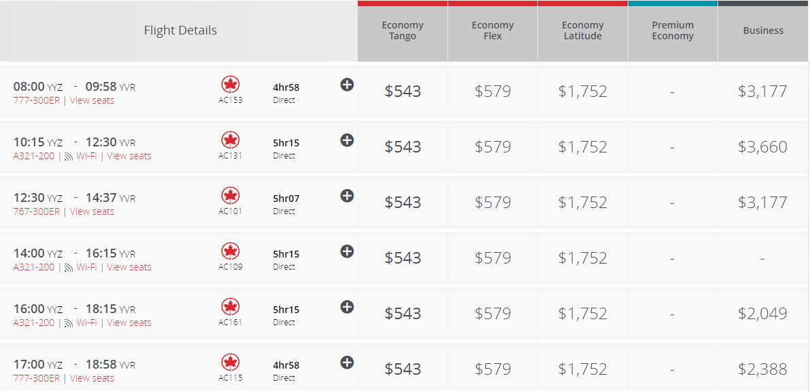
- Below is the flight schedule from Toronto, Ontario to Vancouver, British Columbia on November 12th. Please use it to answer the questions below.
a) How many flights are listed to go to Vancouver? 6 flights
b) What is the duration of the longest flight? 5hrs 15 mins
c) What is the duration of the shortest flight? 4hrs 58 mins
d) What time does flight AC115 leave in 12 hour time? 5:00 pm
e) What time does flight A131 arrive in 12 hour time? 10:15am

Practice Questions:

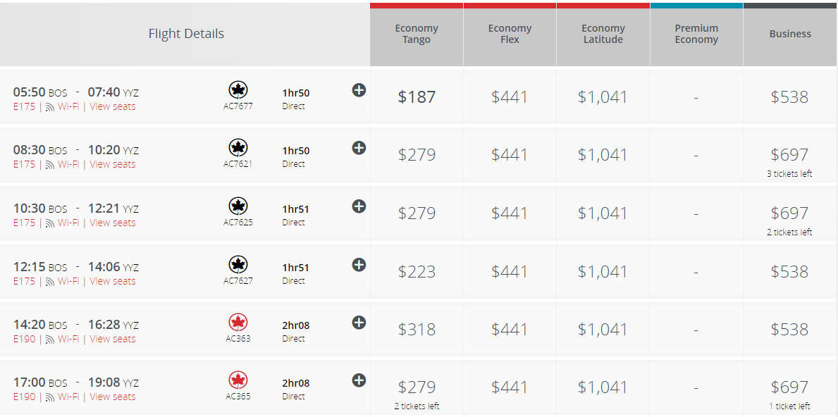
- Below is the flight schedule Boston, Massachusetts to Toronto, Ontario on Dec 17th. Please use it to answer the questions below.

- How many flights are scheduled from Boston to Toronto?

- What time does flight AC7625 depart from Boston using 12 hour time?

- What time does flight AC363 arrive in Toronto using 12 hour time?

- How long is flight AC7621?

- What is the earliest you would be able to leave Boston to get to Toronto?

- If you had to get to Toronto by 3:00pm which flights could you not take?

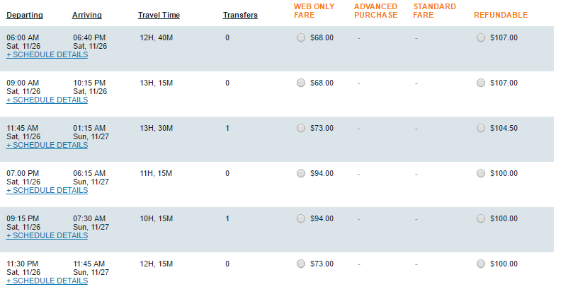
2) Below is a bus schedule from Toronto, Ontario to New York City, New York on Nov 26th. Please use it to answer the questions below.
- What time does the bus that leaves at 9:00am arrive in New York?

- What time does the bus that arrives at 7:30am leave Toronto?

- When does the bus that takes the least amount of time leave Toronto?

- What is the difference in time between the fastest bus and the slowest bus?

3) Below is a train schedule from Brampton, Ontario to Union Station in Toronto. Please use it to answer the questions below.

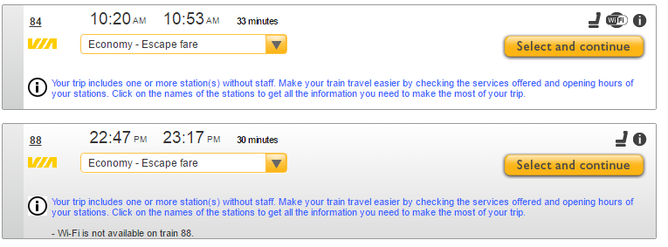

- How many trains leave from Brampton to Union station on this particular day?

- Do they both take the same amount 0f time? If not what is the difference in time?

- Which train would you prefer to take and why?

- When does train 84 arrive at Union Station in 12 hour time?

- When does train 88 arrive at Union Station in 12 hour time?

- If you had to get to Toronto by 1:00pm which train would you take?
4) Below is the schedule of a flight from Vancouver, British Columbia to Saskatoon, Saskatchewan. Please use it to complete questions below.

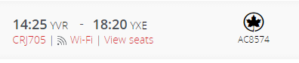

- What time does the flight leave Vancouver in 12 hour time?

- What time does the flight land in Saskatoon in 12 hour time?

- How long is the flight?

- What time should you arrive to the airport if you were to catch this flight? Why?

Strand 2 Lesson 3 Assessment:

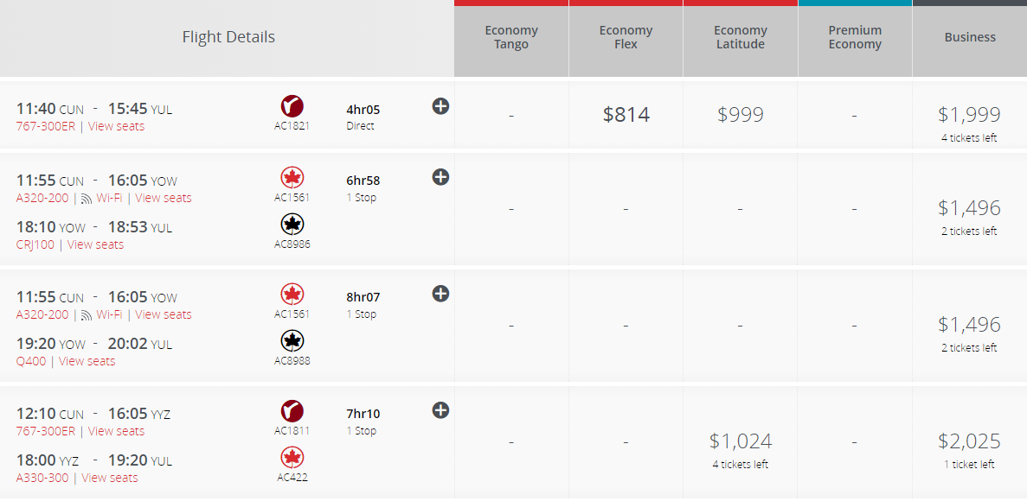
- Below is the flight schedule from Cancun, Mexico to Calgary, Manitoba on Jan 2nd. Please use it to answer the questions below
- If you were travelling to Calgary, which flight would you prefer to take and why?

- What time does flight AC422 arrive in Calgary in 12 hour time?

- What time does flight AC1561 depart from Cancun in 12 hour time?

- How long is flight AC422?

- What is the time difference between the shortest and the longest flight?

- If you had to be in Calgary before 7:30pm which flights would you take?
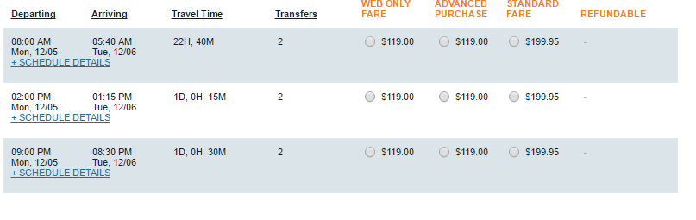
2) Below is a bus schedule from Montreal, Quebec to Chicago, Illinois on Dec 11th. Please use it to answer the questions below.
- How many busses leave from Montreal to Chicago on Dec 11th?

- What time does the bus that leaves from Montreal at 2:00pm arrive in Chicago?

- What time does the bus that arrives at Chicago at 8:30pm leave Montreal?

- How long is the shortest trip?

- If you had to be in Chicago by 11:00am on Tuesday, which bus would you have to take?

3) Below is a bus schedule from London, Ontario to Brampton, Ontario on Nov 30th. Please use it to answer the questions below.
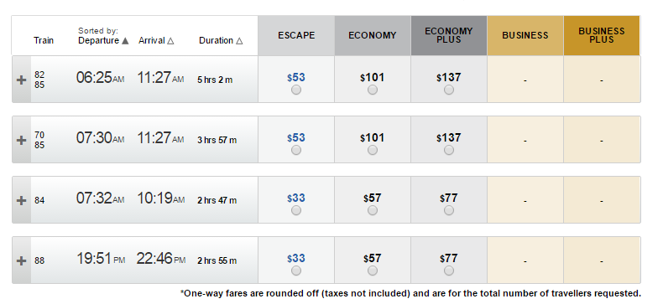

- How many trains leave from London to Brampton on this particular day?

- What is the time difference between the shortest trip and the longest trip?

- Which train do you prefer to take and why?

- What time does train 88 leave London in 12 hour time?

- What time does train 84 arrive in Brampton in 12 hour time?

- If you had to arrive in Brampton by 1:00pm, which trains could you take?

- Which train would you prefer to take and why?

- When does train 84 arrive at Brampton in 12 hour time?

- When does train 88 arrive at Brampton in 12 hour time?

- If you had to get to Brampton by 1:00pm which train would you take?

4) Below is the schedule of a flight from Deer Lake, Newfoundland to Toronto, Ontario. Please use it to complete questions below.

- What is the flight number?

- How long is the flight?

- When does it leave Deer Lake?

- When does it arrive in Toronto?

