Lesson 1: Determining Rates of Pay and Types of Work

Learning Goals:

- Knowing the difference between the various methods of payments
- Reading a job posting accurately
- Calculating possible hourly, daily weekly, monthly and yearly income

Topic: Determining Rates of Pay and Types of Work

It is important to know the difference between different methods of payment before you accept a job.
Method of Pay | Description
Salary | Pays a set amount regardless of the hours you work
Hourly | Pays the same amount for every hour you work
Commission | Pays you a percent of the sales you make
Piecework | Pays a set amount for every task you complete.

It is important to be able to calculate how much you would make in an hour, week, month or a year depending on what information a job posting provides you
It is also important to know the following
- Daily means once a day (365 days per year)
- Weekly means once per week (52 weeks in a year)
- Monthly means once a month (12 months in a year)
- Annually is another word for yearly

Converting from hourly wage to daily salary
Daily salary = (hourly rate) x (hours worked per day)

Converting from hourly wage to weekly salary
Weekly salary = (hourly rate) x (hours worked per day) x (days worked per week)
Or
Weekly salary = (hourly rate) x (hours worked per week)

Converting from hourly wage to monthly salary
Monthly salary = (hourly rate) x (hours worked per day) x (days worked per week)
x (weeks worked per month)

Monthly salary = (hourly rate) x (hours worked per week) x (weeks worked per
month)

Converting from hourly wage to annual salary
Annual salary = (hourly rate) x (hours worked per day) x (days worked per week) x
(weeks worked per year).
Or
Annual salary = (hourly rate) x (hours worked per week) x (weeks
worked per year)

Converting from annual salary to monthly salary
Monthly salary = (annual salary) $÷$ (number of months worked in the year)

Converting from annual salary to weekly salary
Weekly salary = (annual salary) $÷$ (number of weeks worked in the year)

Converting from annual salary to daily wage
Daily wage = (annual salary) $÷$ (number of days worked in a year)

Converting from annual salary to hourly wage
Hourly wage = (annual salary)$÷$ (number of weeks worked in a year)
$÷$ (hours worked per week)

Finding amount of commission earned

Commission earned = $\frac{percent of commission }{100}$x total amount sold

Example(s):

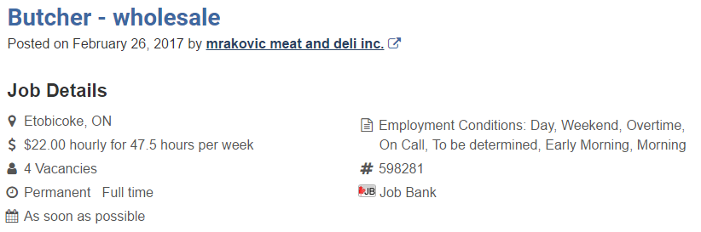
- Use the job post below to answer the following questions

- Is this a permanent job?
According to the job posting, this is a permanent full time position.

b) When would you be required to work if you got this job?
You would be required to work early mornings, days, weekends overtime and be on call.

c) How many hours would you be working a week?
You would be working 47.5 hours per week

d) How much would you earn weekly in this job?
Weekly salary = (hr rate) x (hours worked per week)
Weekly salary = $22.00 per hour x 47.5 hours per week =
$1045
You would earn $1,045 weekly in this job

e) How much would you earn monthly in this job?
Monthly salary = (hourly rate) x (hours worked per week) x (weeks worked in the month)
Monthly salary = $22.00 per hour x 47.5 hours per week x 4 weeks worked in the month = $4, 180
You would earn $4,180 monthly in this job

f) How much would you earn annually in this job?
Annual salary = (hourly rate) x (hours worked per week) x (weeks worked per year)
Annual salary = $22.00 per hour x 47.5 hours per week x 52 weeks worked in the year = $54, 340
You would earn $54,340 annually in this job

2) Use the job post below to answer the following questions

- Where is the location of this job?
This job is located in Montreal, Quebec

- How many hours are you required to work per week if you got this job?
You are required to work 40 hours a week

- Is it a full time job?
Yes, it is a full time permanent job

- Calculate the monthly salary for this job if you earn the minimum?
Monthly salary = (annual salary) $÷$ (number of months worked in the year)
Monthly salary = $80,000/year $÷$ 12 months = $6,666.67
You would earn $6,666.67 monthly at this job.
e) Calculate the weekly salary for this job if you earned the max?
Weekly salary = (annual salary) $÷$(number of weeks worked in the year)
Weekly salary = $90,000 per year$÷$ 52 weeks per year = $1,730.78 per week
You would earn $1,730.78 weekly at this job.

f) Calculate the hourly wage for this job if you earn the minimum?
Hourly wage = (annual salary) $÷$(number of weeks worked in a
year)$÷$ (hours worked per week)
Hourly wage = $80000 $÷$ 52 weeks per year $÷$ 40 hours per week
= $38.46 per hour
The hourly wage you would earn would be $38.46 per hour

3) Use the job post below to answer the following questions.

- Which company would you work for if you got this job?
You will work for Schwartz Furniture

- How many hours would you work a week in this job?
You would work 40 to 50 hours per week.

- What is another perk of this job?
You would receive group insurance benefits

- If you made $15,000 in sales a week how much would you earn a week?
Commission earned = $\frac{5}{100}$x total amount sold

Commission earned = $\frac{5}{100 }$x $15,000 = $750
You would earn $750 a week
Practice Questions:

- Use the job post below to answer the following questions

- What company would you work for if you got this job?

- Where is this job located?

- When would you start working if you got this job?

- How much would you earn weekly at this job?

- How much would you earn monthly at this job?

- How much would you earn yearly at this job?

2) Use the job post below to answer the following questions

- Where is this job located?

- How many hours would you work a week if you got this job?

- How many vacancies does this job has?

- If you made 1500 pieces a week, how much would you earn weekly?

- If you made 5000 pieces a monthly, how much would you earn monthly?

3) Use the job post below to answer the following questions
- Where is this job located?

- When would you start if you got this job?

- What are the maximum hours you would work per week?

- If you made $30,000 in sales a week how much would you earn a week?

- If you made $400,000 in sales a year how much would you earn annually (yearly)?

4) Use the job post below to answer the following questions
- What company would you be working for if you got this job?

- Where is this job located?

- When would you be required to work if you got this job?

- What is the maximum you could earn at this job?

- How much would you earn daily at this job if you worked 48 hours a week and made $50,000 a year?

- How much would you earn weekly at this job if you worked 48 hours a week and made $50, 000 a year?

- How much would you earn monthly at this job if you worked 48 hours a week and made $50, 000 a year?

Assessment: Strand 1 Lesson 1

- Use the job post below to answer the following questions

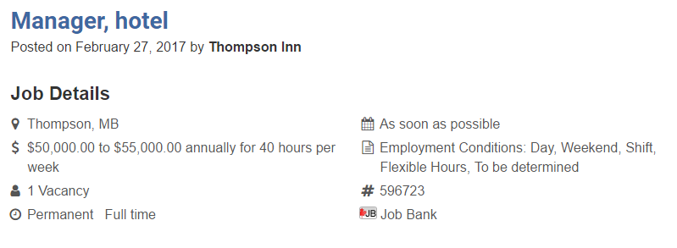

- Where is the location of this job?

- How many hours are you required to work per week if you got this job?

- Is it a full time job?

- Calculate the monthly salary for this job if you earn the maximum?
- Calculate the weekly salary for this job if you earned the max?

- Calculate the hourly wage for this job if you earn the minimum?

2) Use the job post below to answer the following questions

- What company would you work for if you got this job?

- Where is this job located?

- What hours would you be required to work if you got this job?

- How much would you earn weekly at this job?

- How much would you earn monthly at this job?

- How much would you earn yearly at this job?

3) Use the job post below to answer the following questions

- Where is this job located?

- Who would you work for if you got this job?

- How many vacancies are there?

- Would you be full time right away?

- What are the minimum hours you would work per week?

- If you made $20,000 in sales a week how much would you earn weekly?

- If you made $300,000 in sales a year how much would you earn annually?

