Lesson 1: Reading and interpreting different types of graphs

Learning Goals:

- When and how to use a line, bar and pie graph.
- Define and identify the parts of a line and bar graph.
- Examine line graphs presented in examples.
- Read and interpret information from line graphs.

Topic: Reading and interpreting different types of graphs

Graphs (line, bar, or pie graphs) help you communicate information in a format that shows how one piece of information is related to another.
Line graphs can be used to compare changes over the same period of time for more than one group.

Pie charts are best to use when you are trying to compare parts of a whole. They do not show changes over time.

Bar graphs are used to compare things between different groups or to track changes over time.

Example(s):

Let’s first look at line and bar graphs:
A bar or a line graph is used to organize and analyze information about two variables, e.g., weight and cost, time and distance, colour and number.
The horizontal axis (x-axis) is used to show the quantity (e.g. time) or type (e.g. blue) of one of the two variables. This variable is called the independent variable. It’s a variable you can manipulate, but it’s not dependent on the changes in other variables.
The vertical variable (y-axis) is called the dependent variable. The value of y depends on the value chosen for x.
The axes are usually labeled with the name of the variable and units of measure.

Here is an example of how we can use a line graph to compare Mark’s height at different ages.

- How old is Mike when he is 40 inches tall?

- At what age is Mike 42 inches tall?

- How much did Mike grow from when he was 2 years old to when he turned 8 years old?

A pie chart uses “pie slices” to show relative sizes of data.
Each slice is usually represented as a percentage or fraction.
It is a really good way to show relative sizes: it is easy to see which movie types are most liked, and which are least liked, at a glance.

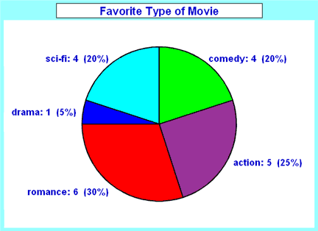

Practice Questions:

Read and interpret each graph below by answering their respective questions.
Question 1:
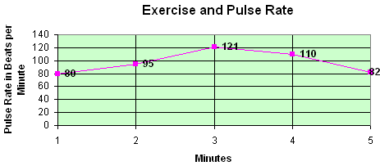

- What is the largest number on the vertical scale?

- What pulse rate is recorded at 4 minutes?

- A pulse rate of 95 beats per minute was recorded at how many minutes?

Question 2:

- How many items are being compared in the graph?

- What was the average height in cm for Xtreme Grow?

- What was the average height in cm for No Fertilizer?

Question 3:

- How many sectors are in this circle graph?

- What percentage of people preferred ginger soda?

- What percentage of people preferred cherry soda?

- If a total of 100 people were surveyed, then how many people preferred vanilla mint soda?
Stand 4 Lesson 1 Assessment:
Answer the questions as it pertain to each graph.
Question 1:

1) What is the title of this line graph?

2) What is the range of the values on the horizontal scale?

3) What is the range of the values on the vertical scale?

4) How many points are on the graph?

5) What is the lowest temperature recorded?

6) What is the highest temperature recorded?

7) At what point did the temperature dip?
Question 2:

1. | What is the title of this line graph?
2. | What is the range of values on the horizontal scale?
3. | What is the range of values on the vertical scale?
4. | How many points are in the graph?
5. | What was the highest value recorded?
6. | What was the lowest value recorded?
7. | Did the value of the car increase or decrease over time?

Question 3: The line graph below shows people in an office at various times of the day.

1. What is the busiest time of day at the office?
2. At what time does the office have the least amount of people?
3. How many people are in the office at 8 am?
4. About how many people are in the office at 1:30 pm?
5. What was the greatest number of people in the office?
6. What was the least number of people in the office?

Question 4: The line graph below shows the number of pre-teens 9 through 13 in Aurora that have cell phones.

- At what age do children have the greatest number cell phones?

- At what age do children have the least number of cell phones?

- How many cell phones do 11 year-olds have?

- About how many cell phones do 12year-olds have?

- What was the greatest number of cell phones at any age?

- What was the least number of cell phones at any age?

